The Cell Cycle Coloring Worksheet

Label the diagram below with the following labels:
- Anaphase
- Interphase
- Interphase
- Interphase
- Mitosis Cell division (M Phase)
- Prophase
- Cytokinesis
- S - DNA replication
- G1 – cell grows
- Metaphase
- Telophase
- G2 – prepares for mitosis
Then on the diagram, lightly color the G1 phase BLUE, the S phase YELLOW, the G2 phase RED, and the stages of mitosis ORANGE. Color the arrows indicating all of the interphases in GREEN. Color the part of the arrow indicating mitosis PURPLE and the part of the arrow indicating cytokinesis YELLOW.
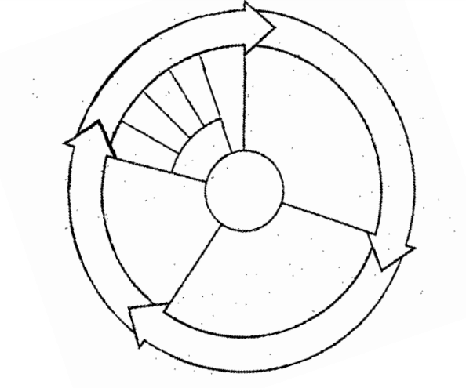
Use the diagram and your notes to answer the following questions.
1. What is a series of events that cells go through as they grow and divide?
2. What is the longest stage of the cell cycle called?
3. During what stage does the G1, S, and G2 phases happen?
4. During what phase of the cell cycle does mitosis and cytokinesis occur?
5. During what phase of the cell cycle does cell division occur?
6. During what phase of the cell cycle is DNA replicated?
7. During what phase of the cell cycle does the cell grow?
8. During what phase of the cell cycle does the cell prepare for mitosis?
9. How many stages are there in mitosis?
10. Put the following stages of mitosis in order: anaphase, prophase, metaphase, and telophase.
11. Put the following stages of the cell cycle in order: G2, S, G1, M.
12. Put the following in order: G2, G1, S, mitosis, cytokinesis.
13. Put the following actions in order: DNA replication, cell grows, cell division, cell prepares for mitosis.
14. Explain why cells don’t just continue to grow larger as organisms grow larger. Why do cells divide? (Write in complete sentences)

