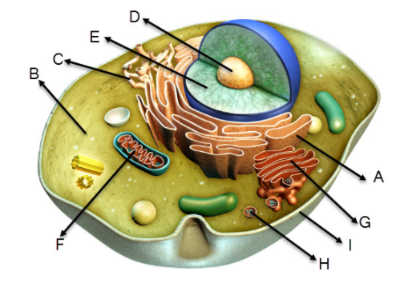

(A) rough endoplasmic reticulum: protein synthesis and packaging
(B) cytoplasm: metabolic reactions
(C) smooth endoplasmic reticulum: lipid synthesis
(D) nucleolus: ribosome assembly
(E) nucleus: storage and replication of genetic material
(F) mitochondrion: cellular respiration
(G) Golgi apparatus: modification and transport of proteins
(H) ribosome: protein synthesis
(I) cell membrane: maintain a barrier with environment and regulate movement of substances into and out of the cell

